More Information

For more information about campus safety and Huston-Tillotson, request a copy of the Annual Security Report. You may obtain a copy at the Campus Safety office.

You may also view a copy on our web site at http://htu.edu/offices/campus-safety

Policies and Regulations

Familiarize yourself with the policies and regulations of the University, particularly in regards to alcohol, drugs, and weapons.

University policies and regulations are detailed in the student handbook, available at http://htu.edu/offices/human-resources.

Parking on Campus

To park on campus requires a student parking permit. The cost is $50.00 for the year and goes on-sell the first week in September.

Any vehicle in violation of parking regulation is subject to immediate removal (towed and impounded) at the vehicle owner's expense.
Spaces designated for disabled persons can be used only by vehicles displaying an appropriate permit. Vehicles illegally parked in such areas are subject to immediate removal (towed and impounded) at the vehicle owner's expense.


Important Contact Information
24-Hour Campus Safety Number

- Main Gate 512.505.3010

- 11th Street Booth 512.505.3012
(North Gate)

- Chalmers Booth 512.505.3013
(West Gate)

You always have access to 911 emergency
assistance. Do not hesitate to contact emergency personnel if you feel the situation warrants urgent attention. Please contact Campus Safety @ 512-505-3010 if you contact 911.

Identification Card (ID)

All students are expected to carry a valid photo identification card issued by Huston-Tillotson University.

There is a replacement cost of $25.00 if cards are lost.

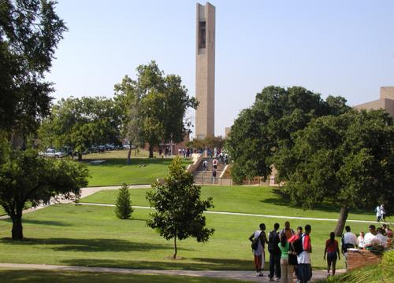

Office of Campus
Safety and Security

HT is I.D.E.A.L



Anthony and Louise-Viaer Alumni Center
Room #200

O: 512.505.3011
F: 512.505.3349
llyork@htu.edu

s

STUDENT INFORMATION
Campus Safety

Huston-Tillotson University Office of Campus Safety and Security is committed to providing a safe and secure environment for students, faculty, staff, and visitors. The primary objectives of the department are to protect and serve members of the campus community.

Safety is no accident! The Office of Campus Safety Security, Student Affairs staff, and local law enforcement all work together to provide a formal structure for ensuring the safest possible surroundings for community members and their property.

In addition to these efforts, the most effective component of any safety program is You!

To Report A Crime

The Office of Campus Safety and Security encourages all students, faculty, staff, and guests to immediately report all criminal incidents and other emergencies occurring on campus. To report a crime or emergency, dial "911" and Campus Safety @ 512.505.3010.

If you See Something Say Something

Don't Become a Victim

In order for a crime to occur, perpetrators must have the ability, the desire, and the opportunity to commit a crime. You can help remove the opportunity. Being safe sometimes means being inconvenienced. Plan ahead and make safety a priority in your life!
Access to Campus Facilities

Access to campus buildings and grounds is
a privilege extended to students, faculty, staff, and guests.

Except for residence halls, most campus
facilities are normally open when classes are in session, or by special arrangements with the events coordinator.

At night and during times when the campus is officially closed, University buildings are locked.

Visitation

Visitation is held Sunday through Thursday – 3 p.m. until midnight; Friday and Saturday from 3 p.m. to 2 a.m. Guest(s) must begin to vacate the residence halls 15 minutes before the end of each evening.

During visitation hours, visitors are required to sign (guest log) into the residence halls. There are no visitors outside of these times. Residence Life staff retain the right to limit visitation hours as necessary.

Guests and visitors to the campus must present a current, valid form of picture identification to Campus Safety when driving onto campus and to the desk staff on duty in the residence halls before visiting a student.

The 11th street gate is locked at 1:00 a.m. nightly. P

Personal Safe ty Tips

Practice Personal Safety Habits

- Keep your room or apartment doors and windows locked at all times.

- Do not leave valuables such as cell phones or electronic devices in plain view in a vehicle.
- Travel in groups after dark.

- Clearly mark all personal property.

Discourage Careless Behavior

- Never let anyone into a residence hall unescorted.

- Never jog or walk alone at night.

- Do not wear headphones while jogging or walking outdoors.

- Protect access and security codes.

Report All Suspicious Activities

- Trespassers or suspicious vehicles

- Erratic or irregular individual behavior

- Vehicle or building alarms

