More Information

The Clery Act requires colleges and universities that receive federal funding to disseminate a public Annual Security Report (ASR) to employees and students every October 1st. ASR includes statistics of campus crime for the preceding 3 calendar years, plus details about efforts taken to improve campus safety.

ASRs also includes policy statements regarding (but not limited to) crime reported, campus facility security and access, law enforcement authority, incidences of alcohol and drug use, and the prevention of sexual assault, domestic or dating violence, and stalking.

A copy of the Annual Security Report may be obtained at the Office of Campus Safety and Security.

You may also view a copy on our web site at http://htu.edu/offices/campus-safety

Parking on Campus

To park on campus requires a student parking permit. The cost is $50.00 for the year and can be purchased the first week in September. Any vehicle in violation of parking regulation is subject to immediate removal (towed and impounded) at the vehicle owner's expense.
Spaces designated for disabled persons can be used only by vehicles displaying an appropriate permit. Vehicles illegally parked in such areas are subject to immediate removal (towed and impounded) at the vehicle owner's expense.
Important Contact Information

- Main Gate 512.505.3010 (24/7)

- 11th Street Booth 512.505.3012
(North Gate)

- Chalmers Booth 512.505.3013
(West Gate)

Emergency Phone Number

You always have access to 911 emergency assistance. Do not hesitate to contact emergency personnel if you feel the situation warrants urgent attention.

HT Identification Card (ID)

Each Huston-Tillotson University student must have an HT identification (ID) card. An official
Huston-Tillotson University Identification Card is issued to each student during registration.

The card serves as identification for admission to athletic events, for book loans from both the Huston-Tillotson University Library and the University of Texas General Libraries, for campus-sponsored events, and for campus security.

There is a $25.00 replacement cost if lost.
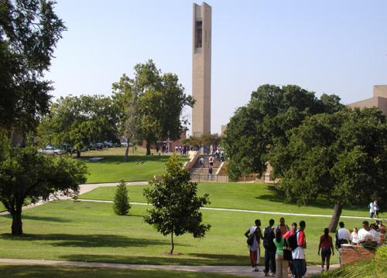
Campus Safety and Security

HT is I.D.E.A.L

Anthony and Louise-Viaer Alumni Center
Room #200

O: 512.505.3011
F: 512.505.3349
llyork@htu.edu

Parent Guide

Campus Safety and Security

Mission
The mission of Campus Safety and Security is to ensure a safe, secure, and orderly campus for students, faculty, staff, alumni, and visitors at Huston-Tillotson University, thereby contributing toward a positive learning environment.

Safety at Huston-Tillotson is a shared responsibility that every member of the University community needs to take seriously. We believe that the key to preventing crime is awareness, which is best achieved through education and communication. Faculty, staff, students, and Campus Safety and Security all work together to promote a safe environment in which to learn. To

Vision
To develop a foundation for providing the highest standard of professionalism, safety, security, community service, and be proactive regarding crime prevention.

Code of Ethics
We are committed to "providing students with an opportunity to succeed" by maintaining the highest standard of ethical and moral behavior, delivering proactive and responsive services to all people, valuing the diversity of the community, and always being mindful of the trust bestowed upon the Office of Campus Safety and Security.

Campus Safety
Campus Safety and Security officers patrol the campus 24 hours per day, 7 days a week, respond to emergencies and other calls for service, walk through the campus buildings, provide escorts upon request or deemed necessary.

Campus Safety and Security encourage all students, faculty, staff, and guests to immediately report all criminal incidents and other emergencies occurring on campus. To report a crime or emergency, dial "911" or Campus Safety @ 512.505.3010.

Access to Campus Facilities

Access to campus buildings and grounds is a privilege extended to students, faculty, staff, and guests.

Except for residence halls, most campus
facilities are normally open when classes are in session, or by special arrangements with the events coordinator.

At night and during times when the campus is officially closed, all University's buildings are locked.

A HT student ID is required to gain entrance to the residence halls at all times.

Visitation

Visitation is held Sunday through Thursday – 3 p.m. until midnight; Friday and Saturday from 3 p.m. to 2 a.m. Guest(s) must begin to vacate the residence halls 15 minutes prior to the end of each evening.

During visitation hours, visitors are required to sign (guest log) to enter the residence halls. There are no visitors outside of these times. Residence Life staff retain the right to limit visitation hours as necessary.

Guests and visitors to the campus must present a current, valid form of picture identification to Campus Safety when driving onto campus and to the desk staff on duty in the residence halls before visiting a student.

Practice Personal Safety Habits

- Keep your room or apartment doors and windows locked at all times.

- Do not leave valuables such as cell phones or electronic devices in plain view in a vehicle.
- Travel in groups after dark.

- Mark all personal property.

Discourage Careless Behavior

- Never let anyone into a residence hall unescorted.

- Never jog or walk alone at night.

- Do not wear headphones while jogging or walking outdoors.

- Protect access and security codes.

Report All Suspicious Activities

- Trespassers or suspicious vehicles

- Erratic or irregular individual behavior

- Vehicle or building alarms
