 NEW MEDIA
 | America Beyond the Color Line with Henry Louis Gates  Special feature: Interview with Henry Louis Gates, Jr.  Gates travels to the east coast, the deep South, inner city Chicago, and Hollywood to investigate modern Black America and interview influential Americans including Colin Powell, Quincy Jones, Samuel L. Jackson, Alicia Keys, Maya Angelou, Willie Herenton and others. (DVD 220 min)  AV DVD 440
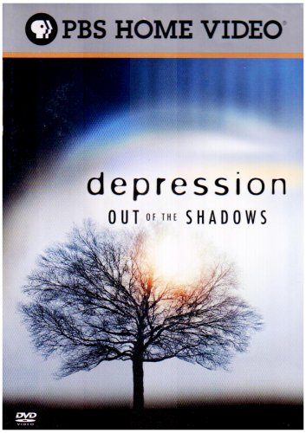 | Depression: Out of the Shadows  "Depression: out of the Shadows tells the dramatic stories of people of different ages, from diverse backgrounds, who live with various forms of depression. Leading mental health experts highlight the latest scientific research and innovative treatments, offering greater understanding and hope for the millions of people living with this complex, but treatable, disease." From container. (DVD 90 min)  AV DVD 441
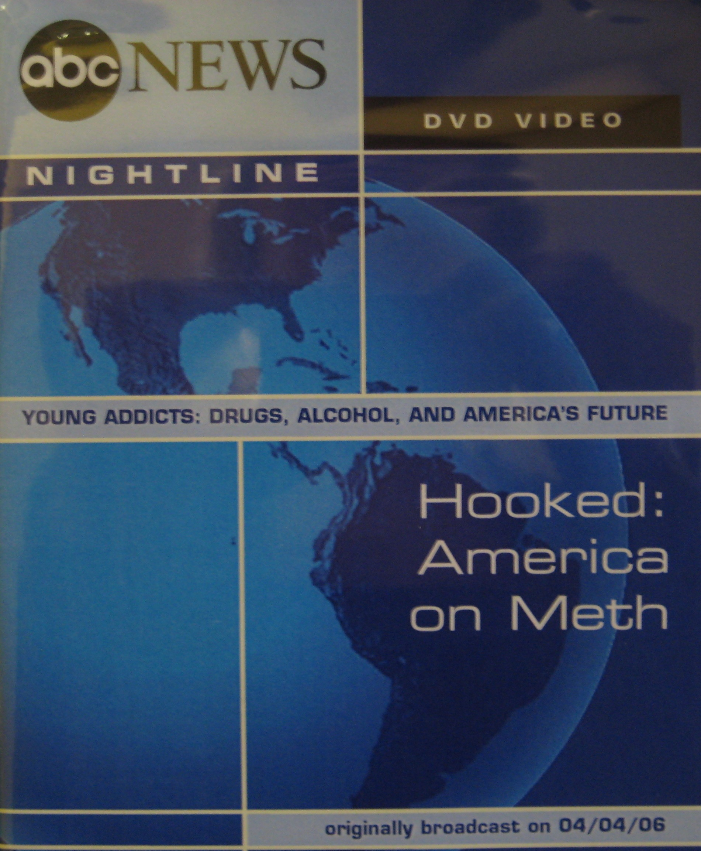 | Hooked: America on Meth  "This ABC news program reports on the Montana Meth Project, an organization undertaking an aggressive plan to "unsell" meth--with an ad campaign designed to frighten Montana’s youth into avoiding the drug. Highlighting the campaign’s gritty imagery and language involving prison, rape and prostitution, the report includes information on the project’s financing, how the ads play out in Montana’s teen demographic, and the need for long-term antidrug programs" -- Container. (DVD 11 min)  AV DVD 444
 | Chemistry and Life  "Students new to chemistry might think it’s all about beakers and test tubes. You can use this title in the Molecular Universe series to show them what chemistry is really about -- the foundation of life, and the innovations that make life better. Outlining Earth’s early development and the creation of the first organic substances, the DVD focuses on what humanity has been able to accomplish, and what challenges the future holds, in the field of chemistry. Resins, fibers, and plastics that have revolutionized human activity are showcased, especially in the world of sports, with its radically engineered lightweight equipment, and the stunning example of NASA’s solar-powered Helios aircraft"--Container. (DVD 30 min) AV DVD 442
 | Black Death in Dixie: Racism and the Death Penalty in the United States  Portrays capital punishment as an instrument that disproportionately targets racial minorities and the poor. Highlights statistics on the racial makeup of America’s death row population, mistaken identification, the toll on those wrongfully convicted, and the effects of the Jim Crow era. (DVD 26 min)  AV DVD 443
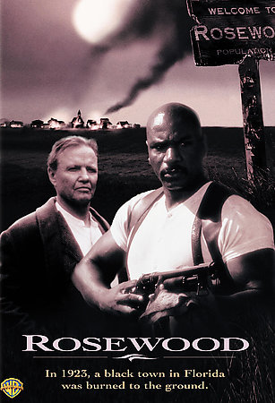 | Rosewood  The true story of the 1923 razing of a black town in Florida, many of its people murdered over a lie. But some escaped and survived because of the courage and compassion of a few extraordinary people. (DVD 142 min)  AV DVD 471
Easy Ways to Use E-Learning

"As e-learning assumes a growing role in professional development, many teachers remain unsure about how to incorporate it. Meanwhile, students use technology in nearly every aspect of their lives and largely expect e-learning to be a part of their education. This program helps beginning and veteran teachers stay relevant in the area of instructional technology, providing practical, stress-free examples of successful e-learning. Viewers discover how laptops, handheld devices, interactive whiteboards, and cameras can be used in the classroom environment to enrich the student’s experience and boost his or her academic development"--Film Media Group website. (DVD 25 min)

AV DVD 430
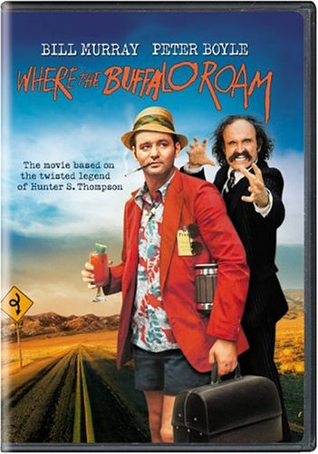 | Where the Buffalo Roam  An off-the-wall comedy about America’s leading "Gonzo" journalist, Dr. Hunter S. Thompson, the legendary underground reporter. (DVD 100 min)  AV DVD 469
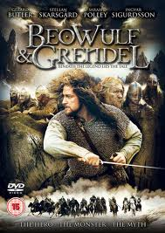 | Beowulf & Grendel  Features: Wrath of gods: a mini documentary, audio commentary by director Sturla Gunnarsson and by screenwriter Andrew Rai Berzins, interviews with major cast, deleted scenes.  A retelling of the epic tale in which the soldier Beowulf sets out to destroy the vengeful monster Grendel but has doubts when he learns that acts of the king he serves may have much to do with Grendel’s behavior. (DVD 103 min)  AV DVD 406
 | OutFoxed: Rupert Murdoch’s War on Jouralism  "This Special Edition Dual-Layer DVD includes all of the infamous "Fox Attacks!" shorts, a series of 18 videos that continues the work started in Outfoxed, highlighting examples of Fox’s biased, dishonest journalism. The videos were created to support campaigns, petitions and legislation, and are presented on this DVD with exclusive commentary tracks;"--Cover.  Examines Rupert Murdoch’s Fox News media empire and the dangers inherent in large corporations controlling the public’s right to know. Includes interviews with former Fox News employees and media experts. (DVD 77 min)  AV DVD 434
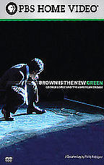 | Brown is the new Green: George Lopez and the American Dream  Film examining how efforts to profit from Hispanic American culture have contributed to the shaping of its contemporary identity. The documentary’s focal point is comedian George Lopez, an icon and advocate for Hispanic Americans’ move into the mainstream. Features conversations with members of the Hispanic American youth market. Also includes interviews with Lopez and other Hispanic Americans. (DVD 60 min)  AV DVD 439
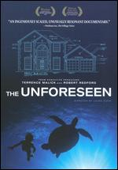 | The Unforeseen  "The American Dream of owning a house with white picket fence goes head-to-head with environmental sustainability... When an ambitious real estate developer sets out to transform thousands of acres of pristine hill country in Austin, Texas into a suburban development - threatening a nearby natural spring - the community fights back. In the conflict that ensues, we see in miniature a struggle that is playing out in cities and towns across the country" -- Container. (DVD 92 min)  AV DVD 435
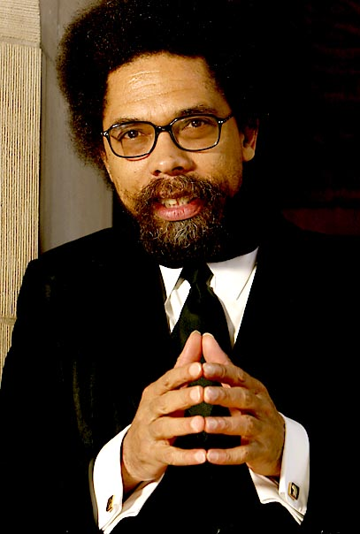 | Religion, Rap, and the Crisis of Black Leadership: Cornel West  A conversation and interview with Cornel West, professor at Princeton University, about religion, rap music, and the crisis of black leadership in America. (DVD 30 min)  AV DVD 449
 | Challenging Hispanic Stereotypes: Arturo Madrid  Moyers and Madrid discuss the controversy surrounding bilingual education and the state of education, in general, for Hispanic people. (DVD 30 min)  AV DVD 438
Order in the Court

In this program, various legal experts explain pretrial and trial procedures, pointing out along the way differences in juvenile proceedings. Judges and lawyers navigate the pretrial process, beginning with the establishment of probable cause and formal charging by grand jury. Indictment, pretrial release, bail, and arraignment are also discussed. Such concepts as an alibi, burden of proof, and reasonable doubt are clearly explained. Finally, a panel of experts comments on a sentencing hearing and punishment, along with the defendant’s constitutional right to appeal. (DVD 30 min)

AV DVD 454
 | E-Mail Alert: How e-mail becomes e-evidence  Learn how deleted e-mails are retrieved and how those indiscreet bits of e-evidence are influencing litigation and causing consternation for companies in North America. (DVD 10 min)  AV DVD 453
 | CyberSense Cyber Security  "The Internet offers vast possibilities for learning, making a living, and having fun - but it can also destroy reputations, empty bank accounts, and ruin lives. This program cautions students about potential hazards to their computers - not to mention their careers, finances, and futures - that exist online. Highlighting the importance of setting up a firewall and keeping one’s operating system up-to-date, the program provides straightforward advice about protecting against hackers, viruses, Trojan horses, spyware, adware, phishing emails, and other high-tech threats. Each concept is defined in user-friendly terms. More basic but equally vital steps like maintaining multiple passwords and not sharing personal information are also discussed. Commentary from experts, as well as questions from peers about the details of computer safeguards, will help students increase their online security"--Container. (DVD 20 min)  AV DVD 452
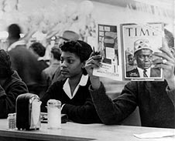 | The Strange Demise of Jim Crow  Told by the participants themselves, this documentary reveals the behind-the-scenes compromises, negotiations, and the controversial news black-outs which helped bring about the quiet desegregation of commercial establishments in Houston, Texas. (DVD 57 min)  AV DVD 448
 | The Physics in Baseball  Shows the various physical forces at play in the pitch, the hit, the flight of the ball and the run around the bases. (DVD 24 min)  AV DVD 445
 | World Music Portraits: Salif Keita  Salif Keita, performer of traditional Malian music on acoustic guitar and music fusing Malian roots with jazz, funk, Europop and R & B, takes us on the road from his current home outside of Paris back to Mali. Includes performances of many of Salif’s most popular songs including ’Yelen’na’, ’Folon’, and ’Mandjou’. (DVD 50 min)  AV DVD 472
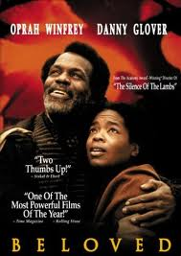 | Beloved  After Paul D. finds his old slave friend Sethe in Ohio and moves in with her and her daughter Denver, a strange girl comes along by the name of "Beloved". Sethe & Denver take her in and then strange things start to happen. (DVD 171 min)  AV DVD 423
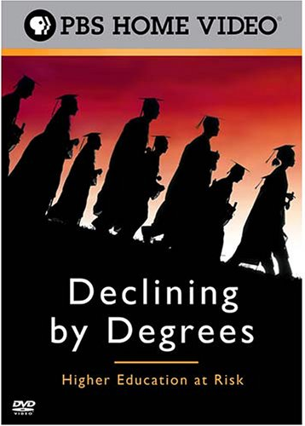 | Declining by Degrees: Higher Education at Risk  This documentary, set on four different college campuses, examines both the promise and the peril in higher education today. (DVD 120 min)  AV DVD 429
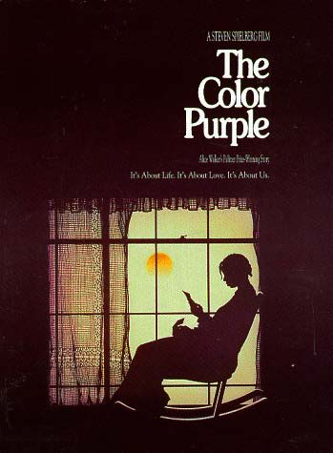 | The Color Purple  The heart-wrenching story of a young black girl in the early 20th century who’s forced into a brutal marriage and separated from her sister. (DVD 154 min)  AV DVD 460
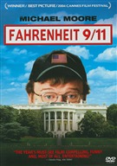 | Fahrenheit 9/11  Special features: "The release of ’Fahrenheit 9/11’" featurette; montage: the people of Iraq on the eve of invasion; new scene: Homeland Security, Miami style; outside Abu Ghraib Prison; Eyewitness account from Samara, Iraq; Extended interview with Abdul Henderson; Lila Lipscomb at the Washington, D.C. premiere; Arab-American comedians - their acts and experiences after 9/11; Condoleezza Rice’s 9/11 Commission Testimony; Rose Garden press briefing after 9/11 Commission appearance. (DVD 122 min)  AV DVD 474
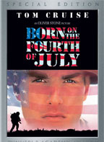 | Born on the Fourth of July  Based on the true story of Ron Kovic, a young man who volunteered for the Vietnam War, was wounded, and returned paralyzed from the mid-chest down. He later became a new voice for those disenchanted with the war. (DVD 145 min)  AV DVD 468
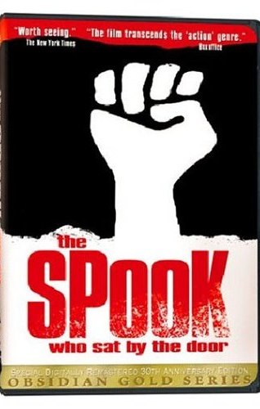 | The Spook Who Sat By The Door  Disgusted by tokenism at the C.I.A., a black agent organizes a revolution against the government. Based on the novel by Sam Greenlee. (DVD 102 min)  AV DVD 470
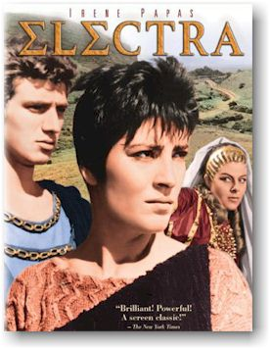 | Electra  Desolation and despair reign supreme in the kingdom of Mycenae. The great Agamemnon has been brutally murdered; his son Orestes has fled and his daughter Electra has been imprisoned within the walls of the castle. All hope seems lost until the sacred oracle speaks and replaces Electra’s broken spirit with an unquenchable desire for justice and bloody vengeance. (DVD 113 min)  AV DVD 463
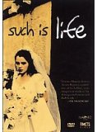 | Such is Life  "Poor and uneducated, Julia lives in a seedy barrio in Mexico City where she practices homeopathic medicine and performs abortions to support her family. When her husband abandons her for another woman, Julia’s world crumbles. She is thrown out of her apartment by her landlord -- soon to be her husband’s new father-in-law -- and her children are about to be taken away from her. With the help of her godmother, she plans to take revenge on her low-life, opportunistic husband." -- Container.  In Spanish with optional English or Spanish subtitles. (DVD 98 min)  AV DVD 409
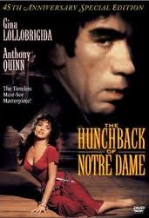 | The Hunchback of Notre Dame  The beautiful Esmeralda befriends Quasimodo, the mysterious hunchback who hides in the bell tower of Notre Dame Cathedral. Based on the novel by Victor Hugo. Originally produced as motion picture in 1956. (DVD 110 min)  AV DVD 407
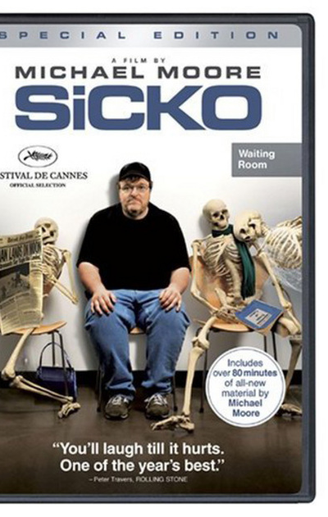 | Sicko  Filmmaker Michael Moore critiques the American health care system, focusing especially on the HMOs, drug companies, and congressmen who profit from the status quo. Also includes an analysis of the health care systems in Canada, England, France and Cuba, where free universal health care is the norm. (DVD 123 min)  AV DVD 467
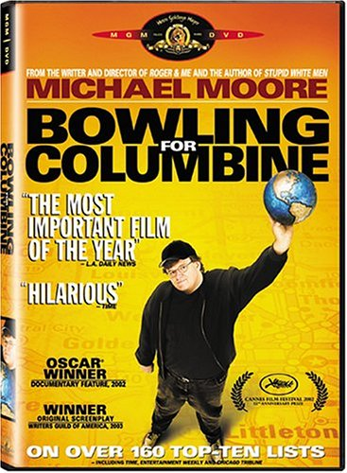 | Bowling for Columbine  The United States of America is notorious for its astronomical number of people killed by firearms for a developed nation without a civil war. With his signature sense of angry humor, activist filmmaker Michael Moore sets out to explore the roots of this bloodshed. (DVD 119 min)  AV DVD 401
 | Sound Tracks: Music without Borders  Marco Werman and the Sound Tracks reporting team travel deep into the heart of international music. They trace the legend of Afrobeat creator and superstar Fela Kuti; examine the raging popularity of Vladimir Putin’s sexy propaganda song; find out if music can help the creators of Borat make amends with the insulted people of Kazakhstan; and capture the mood of a cozy Portuguese bar with diva Mariza -- container. (DVD )  AV DVD 496
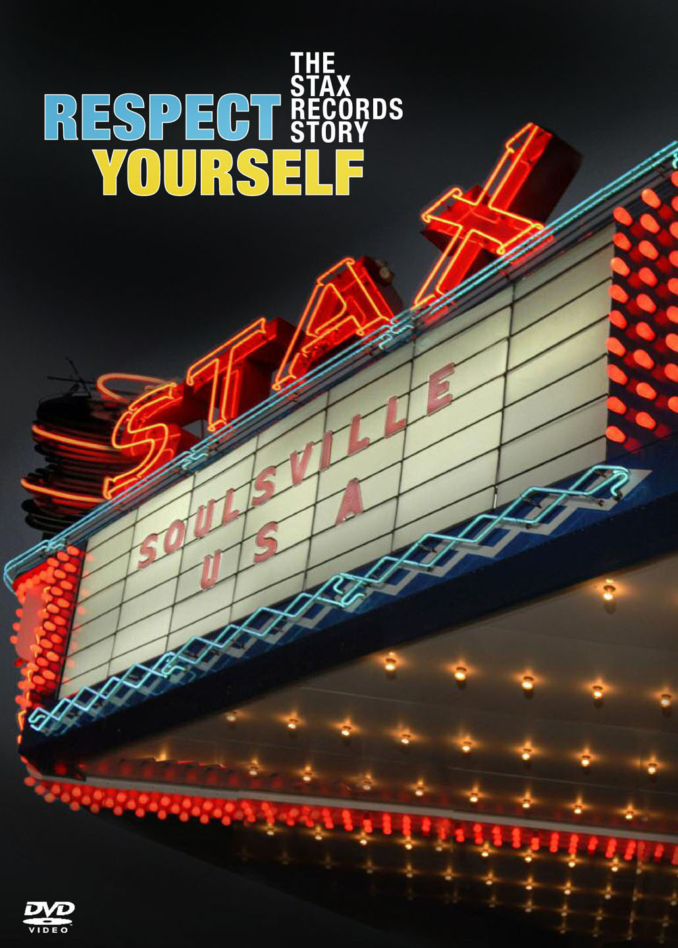 | Repect Yourself: The Stax Records Story  With rare performances, previously unreleased home movies and new recordings, filmmakers Robert Gordon and Morgan Neville present the first comprehensive look at Stax Records, the greatest soul label of all time. Provides first-hand accounts of what really happened on the streets and behind studio doors from celebrated musicians such as Isaac Hayes, Booker T. Jones, Steve Cropper and Mavis Staples, as well as label president Al Bell, Rev. Jesse Jackson and others. (DVD 114 min)  AV DVD 498
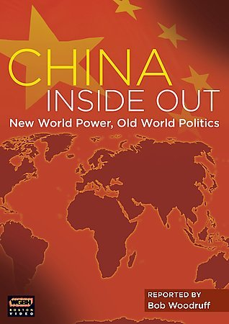 | China Inside Out: New World Power, Old World Politics  After 300 years of relative isolation, China is reaching out to the rest of the world looking for resources, food, friends, and safe places to invest its new fortune. Follow this still-unexplored story of the stunning global transformation taking place. (DVD 42 min)  AV DVD 489
 | Third Ward TX: A Documentary about Art, Life and Real Estate  Third Ward TX is a one-hour documentary about a group of artists finding inspiration in the remnants of a besieged black neighborhood’s storied past. House by house they worked alongside residents and local volunteers to craft a stunning new vision of what could be. In the process, these artists-turned-activists transformed lives - starting with their own. Third Ward TX is a revealing look at a community’s struggle to survive - from segregation to the limited promise of integration, from drug wars to the economic challenges of gentrification. (DVD 60 min)  AV DVD 478
 | The Madoff Affair  Presents an account of the crimes of Wall Street swindler Bernard Madoff. (DVD 56 min)  AV DVD 491
 | Core Biology  Presents the principles of biology by way of a timeline featuring the historic milestones of the respective fields: Plant Sciences, Animal Science, Environmental Science, Microbiology and Genetics (DVD/4 discs 137 min)  AV DVD 508
 | Power for Sports Performance  Through a series of self-assessments, one will identify areas of improvement and establish a baseline for a training regimen. Then learn the exercises that are best for enhancing power in sport-specific movements starting with base-building exercises for developing basic strength and postural control, and advancing to a complex power program that combines resistance training and plyometrics. (DVD 39 min)  AV DVD 455
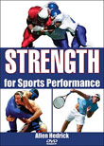 | Strength for Sports Performance  "Bring your strongest effort to the field, court, or mat. Strength for Sports Performance provides the tools to build a program for your needs, your sport, and your goals"—Container. (DVD 25 min)  AV DVD 426
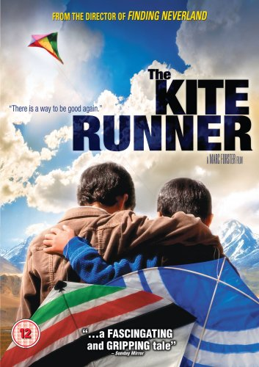 | The Kite Runner  In a divided country on the verge of war, two childhood friends, Amir and Hassan, are about to be torn apart forever. It’s a glorious afternoon in Kabul and the skies are bursting with the exhilarating joy of a kite-fighting tournament. But in the aftermath of the day’s victory, one boy’s fearful act of betrayal will mark their lives forever and set in motion an epic quest for redemption. Now, after twenty years of living in America, Amir returns to a perilous Afghanistan under the Taliban’s iron-fisted rule to face the secrets that still haunt him and take one last daring chance to set things right. (DVD 127 min)  AV DVD 457
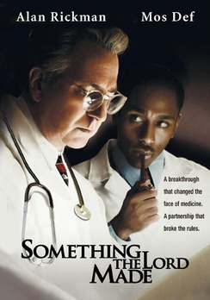 | Something the Lord Made  Tells the emotional true story of two men who defined the rules of their time to launch a medical revolution, set against the backdrop of the Jim Crow south. Working in 1940s Baltimore on an unprecedented technique for performing heart surgery on "blue babies", Dr. Alfred Blalock and lab technician Vivien Thomas form an impressive team. As Blalock and Thomas invent a new field of medicine, saving thousands of lives in the process, social pressures threaten to undermine their collaboration and tear them apart. (DVD 110 min)  AV DVD 402
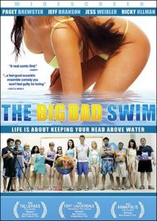 | The Big Bad Swim  A Connecticut adult swim class sets the stage for this comedy-drama about love, loss and second chances. Three strangers, inextricably connected through personal heartbreak, find themselves entering deep water as they learn that life isn’t always about diving right in-- it’s about getting your feet wet once in awhile. (DVD 93 min)  AV DVD 403
 | Sierra Leone’s Refugee All Stars  Uplifting and courageous, this dramatic seven-time award-winning film by Zach Niles and Banker White tracks the journey of a group of six musicians who formed a band after being displaced from their home during a brutal decade long civil war. (DVD 80 min)  AV DVD 497
 | Flexibility for Sports Performance  Helps athletes identify areas of improvement and establish a baseline for his/her flexibility regimen. Demonstrates the best science-based exercise techniques to avoid injury and optimize muscle function on the court, field, course, track, mat, or in the water. (DVD 51min)  AV DVD 425
 | Speed for Sports Performance  "Increase your acceleration, maximum speed, and endurance! Speed for Sports Performance provides the tools to build a program for your specific needs, sports, and goals"--Container. (DVD 55 min)  AV DVD 411
To Infinity and Beyond: Mathematics in Modern Times (The Story of Math)

In the last program in the Story of maths series for BBC FOUR, Marcus du Sautoy, Professor of Mathematics at the University of Oxford, escorts viewers through the history of mathematical ideas and looks at some of the great unsolved problems that confront mathematics in the twentieth century, offering clear, accessible explanations of important mathematical ideas as well as telling the stories, through the use of engaging anecdotes and fascinating biographical details, of the mathematicians who would try to crack them including Georg Cantor, Henri Poincaré, Kurt Godel, Paul Cohen, André Weil, and Alexander Grothendieck. The program concludes by considering one of the great as-yet-unsolved problems of mathematics: the Riemann Hypothesis. (DVD 58 min)

AV DVD 419
 | The Secret Life of Bees  Lily Owens is a young girl who lives on the peach farm that her abusive father owns. Rosaleen is a black woman hired by Lily’s father to be a stand-in mother for Lily. When Rosaleen and Lily walk into town they are approached by some white men. Rosaleen insults these racists by standing up for her rights. The angry men give her a beating and she ends up in the hospital. Lily’s father rescues Lily but not Rosaleen so Lily talks Rosaleen into running away. They end up in a town that Lily believes her mother once lived in. They go to live with the three Boatwright sisters on their honey farm, and there Lily finds solace in the mesmerizing world of beekeeping. (DVD 110 min)  AV DVD 458
 | The Wonderful World of Albert Kahn  Middle East: The Birth of Nations/Albert Kahn’s Archive of the Planet  "No sooner had Europe declared an end to its Great War than the seeds of new conflict were sewn -- in the dismemberment of the Ottoman Empire. With typical global awareness, photography patron and archivist Albert Kahn chose to document the historic changes occurring in the colonial Middle East. This program traces his team’s expeditions into Turkey, Syria, Lebanon, and Palestine as Western powers redrew the map of the region." From container. (DVD 52 min)  AV DVD 432
 | To Kill A Mockingbird  The setting is a dusty Southern town during the Depression. A white woman accuses a black man of rape. Though he is obviously innocent, the outcome of his trial is such a foregone conclusion that no lawyer will step forward to defend him-- except the town’s most distinguished citizen. His compassionate defense costs him many friendships but earns him the respect and admiration of his two motherless children. Based on the novel by Harper Lee. (DVD 130 min)  AV DVD 436
The Living Machine: One-Degree Factor

Drawing astonishing connections between forces thousands of miles apart, this program shows how life on earth is being pushed to extremes by a one-degree rise in average temperature. Specific topics include animal population declines, atmospheric developments above the oceans, and the widespread appearance of a previously rare respiratory illness. Viewers learn how many scientists believe these disparate phenomena are directly linked to global climate change. (DVD)

AV DVD 420
Knowledge Management

Three modules compare various corporate learning systems. Case studies feature Arthur Andersen, the European Automobile Manufacturers Association, Dailmer Benz, Volvo amd ABB. (DVD 30 min)

AV DVD 450
 | Goin’ to Chicago  A group of longtime Chicago residents returns to Greenville, Mississippi for a reunion with family and friends. Participants talk about their lives and their reasons for moving north. Includes archival footage of Mississippi and Chicago. (DVD 71 min)  AV DVD 451
Blogging in the Classroom

"Blogs may be driving print journalists out of a business, but they’re doing wonders for the teaching profession. This program helps educators learn more about blogging and the best ways to integrate it into the classroom." -- container. (DVD 24 min)

AV DVD 417
Podcasting in the Classroom

"... Learn how podcasts can disseminate class lectures, additional lecture notes, and study guides while opening up alternative teaching perspectives, bridging the gap with disabled learners, and building media literacy."-- container. (DVD 24 min)

AV DVD 418
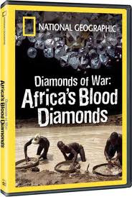 | Diamonds of War: Africa’s Blood Diamonds  Examines the black market diamond trade in Sierra Leone, which for years has funded armed civil insurrection. (DVD 56 min)  AV DVD 427
 | Bright Star  Nineteenth century poet John Keats and the girl next door, Fanny Brawne, started out as unlikely lovers who were totally at odds with each other. However, when Brawne offers to help Keats nurse his seriously ill brother, the two soon became involved in an unstoppable romance that only his untimely death at age 25 could bring to a shattering end. (DVD 119 min)  AV DVD 433
 | “Will you Marry Me?” Marriage Customs in Ethiopia, Mali, Niger and Senegal  "Even today, the majority of African women in both city and country still aspire to get a good husband and have many children. This program sheds light on the pros and cons of marriage customs in sub-Saharan Africa..."--Container. (DVD 49 min)  AV DVD 428
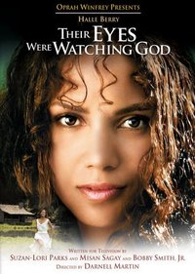 | Their Eyes Were Watching God  A drama set in the 1920s, where free-spirited Janie Crawford’s search for happiness leads her through several different marriages, challenging the mores of her small town. Based on the novel by Zora Neale Hurston. (DVD 113 min)  AV DVD 459
 | The Secret Life of the Brain  This series explores the startling new map of the brain that has emerged from the past decade of neuroscience and shares a revelatory view of this most complicated organ, which now contradicts much of what we previously believed. Narrated by actress Blair Brown, the series tells stories through a mix of personal histories, expert commentary and cutting-edge animation. Viewers will not only learn startling new truths about the brain, they will voyage inside it. (DVD/3 disc set 300 min)  AV DVD 722
 | World in Balance  In Japan, Europe and Russia, birth rates are shrinking and the population is aging. In parts of India and Africa, more than half of the still growing population is under 25. The world population is now careening in two dramatically different directions. China revs up examines China’s booming economy and the impact it’s having on the environment. (DVD 120 min)  AV DVD 384
 | Influenza 1918  In the spring of 1918, an army private reported to a hospital in Kansas. He was diagnosed with the flu, an illness that doctors knew little about. By the end of WWI, America was ravaged by a flu epidemic that killed 675,000 people. (DVD 60 min)  AV DVD 385
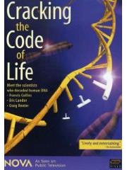 | Cracking the Code of Life  This documentary examines the complex race to decode the human genome. Examines the work of, and contains interviews with: Francis Collins, director of the National Center for Human Genome Research; J. Craig Venter, head of its rival, the private Celera Genomics; and the Whitehead Institute’s Eric Lander, one of the leaders of the Human Genome Project. (DVD 116 min)  AV DVD 386
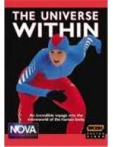 | The Universe Within  Using microphotography to explore the hidden world inside the human body, this program covers three incredible team efforts: the coordination of muscles, bones, heart and circulatory system that makes Mike Powell the world’s greatest long jumper ; the digestive dynamo that turns a simple sandwich eaten by five-time Olympic gold medalist Bonnie Blair into raw energy for a blistering sprint down the ice ; and, the ultimate event--the development of a new human life inside track star Karen Hatchett. (DVD 60 min)  AV DVD 387
 | The Miracle of Life  Disc 1. Shows the actual conception and development of a baby. Looks inside the male and female reproductive organs to show the formation of sperm and the passage of a fertilized egg through the fallopian tube. Uses a microscope to observe DNA, chromosomes, and other minute body details building up to the moment of birth. Disc 2. Bonus DVD, NOVA: life’s first feelings: Reveals the surprising emotional capabilities of newborns and very young children. (DVD/2 discs set 112 min)  AV DVD 388
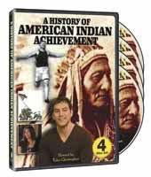 | The History of American Indian Achievement  This original, eight-part series on four volumes, documents the history of American Indian achievement, its defining role in the growth of the country, and its influence on current events. The series highlights the many contributions of American Indians that have influenced and shaped the history of the United States. (DVD/4 disc set 240 min)  AV DVD 389
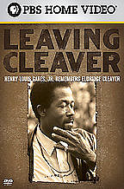 | Leaving Cleaver  A look at the last interview given by Eldridge Cleaver, social activist, former Black Panther, and author, before his death. Features commentary from Cleaver’s former wife, audio tapes of a 1975 interview Cleaver gave, and more. (DVD 60 min)  AV DVD 390
 | Epidemics: Ebola, AIDS, Bird Flu and Typhoid  In 1906 in America it was first discovered that humans could transmit typhoid fever. This is a dramatization of the outbreak and a profile of Irish cook Mary Mallon, known as ’Typhoid Mary’. Quarantined against her will, the story reveals the newfound power of health officials to protect the masses, often at the expense of personal liberties. (DVD/4 disc set 225 min)  AV DVD 391
 | The Choice 2008  "The choice 2008 draws on in-depth interviews with the advisers, family and friends closest to these unlikely candidates, as well as with seasoned observers of American politics, who together tell the definitive story of these men and their ascent to their party’s nominations"--Container. (DVD 120 min)  AV DVD 393
 | The War of the World: A New History of the 20th Century  "The film considers the unparalleled stretch of violence during the 20th century as a single, unrelenting ’war of the world’ that began with Japan’s invasion of Russia in 1904 and continued through the Korean War all the way to an ongoing ’Third Word’s War’"--Container. (DVD 180 min)  AV DVD 394
 | Dreams of Obama  Tells the story of how a little known state senator rose from obscurity to the White House in just over four years. Draws on interviews with those closest to Obama to provide insight into how he might lead the country. A personal and political biography, the film examines the key moments that shaped Obama, and asks what his election says about America. Examines how Obama’s life experiences made him uniquely suited to launch his successful campaign to become the country’s first black president. (DVD 56 min)  AV DVD 398
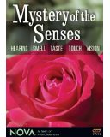 | Mystery of the Senses  A series of five programs inspired by Diane Ackerman’s book A natural history of the senses, each examining one of the senses. (DVD/5 disc set 220 min)  AV DVD 399
 | Nutrition Teaching System Series: The Digestive System, Carbohydrates, Fats, Proteins, Vitamins, Minerals, Water Combo, Energy Balance, Weight Control & Metabolism, and Disease Prevention  Cerebellum Teaching Systems are simply the most effective method for students to learn and for teachers to teach. These innovative systems cover 10 core subjects and include a Standard Deviants School DVD with extra content and a CD-ROM filled with classroom notes, quizzes, games, discussion questions, and graphic handouts. Each program correlates directly to government standards for the subject is designed by teaching professionals recognized for their expertise. (DVD/10 disc set 172 min)  AV DVD 510
 | 25 Most Influential Business Persons of the Past 25 Years  Who are the 25 most influential persons in business, finance and economics since NBR first took to the air in 1979? NBR and the Wharton School of Business of the University of Pennsylvania set out to answer that question. Those who qualified for this list are profiled in this program. (DVD 46 min)  AV DVD 495
 | Spanish: The Irregular Verbs Tener & Querer; Making Verbs Negative  Learn the basics of the Spanish language. (DVD 15 min. each)  AV DVD 412
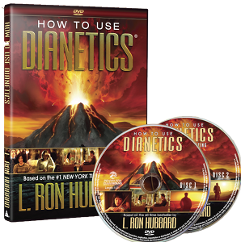 | How to use Dianetics-- Based on the #1 New York Times bestseller by L. Ron Hubbard  This two-disc DVD is a companion to Dianetics: The Modern Science of Mental Health, the most widely read and broadly acclaimed book ever written on the subject of the human mind. Drawn directly from the pages of the book, these films reveal how negative experiences in your past cause your mind to depart from rational thought and behavior—without you even knowing it. What’s more, these films teach you exactly how to use a precise Dianetics procedure of auditing to locate these past experiences and eliminate their negative effects. (DVD/2 disc set 4 hrs. 23 min)  AV DVD 461
 | Jazz Icons: Art Blakey & the Jazz Messengers : live in ’58 / Dizzy Gillespie : live in ’58 and ’70 / Louis Armstrong : live in ’59 / Quincy Jones : live in ’60 / Thelonious Monk : live in ’66 / Buddy Rich : live in ’78 / Ella Fitzgerald : live in ’57 and ’63 / Count Basie : live in ’62 / Chet Baker : live in ’64 and ’79  "Jazz Icons is an ongoing DVD series featuring full-length concerts and in-studio performances by the greatest legends of jazz, filmed all over the world from the 1950s through the 1970s"--Container of Chet Baker disc. (DVD/9 discs 9 hr., 55 min)  AV DVD 509
 | Empire of the Air: The Men Who Made Radio  Story of radio from 1906-1955 and the three men who made it happen: Lee de Forest, Edwin Howard Armstrong, and David Sarnoff. Combines archival photographs, newsreels of the period, interviews, and radio soundtrack. (DVD 120 min)  AV DVD 499
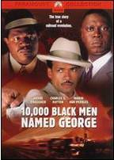 | 10,000 black men named George  The true story of the formation of the first black-controlled union, the Brotherhood of Sleeping Car Porters. As Philip Randolph, a black journalist, establishes a voice for the forgotten workers of the Pullman Rail Company, were all black porters were simply named "George", after George Pullman, the first person to employ emancipated slaves. (DVD 89 min)  AV DVD 400
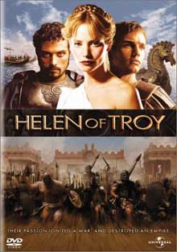 | Helen of Troy  A re-telling of the classic tale of power and corruption, moved by the passions and desires of towering personalities. Aphrodite promises the most beautiful woman in the world to Paris, Prince of Troy, but alas, Helen is already married to Menelaus King of Sparta, brother of Agamemnon. When she escapes to Troy with Paris, Menelaus rallies the kings of Greece to attack Troy. Also included are the prophecies of Cassandra, the sacrifice of Iphigenia, the duel between Hector and Achilles, and even crafty Odysseus makes an appearance. In a return to grand Hollywood tradition, the battle scenes feature a ’cast of thousands’ rather than CGI effects. (DVD 177 min)  AV DVD 408
Accounting: The Basics

The Standard Deviants introduce you to the basics of accounting, including GAAP. You’ll learn about owner’s equity, the three types of business organizations, the five types of accounts, and three types of financial statements. It’s fun, it’s feisty, it’s financial accounting, that is. (DVD 26 min)

AV DVD 415
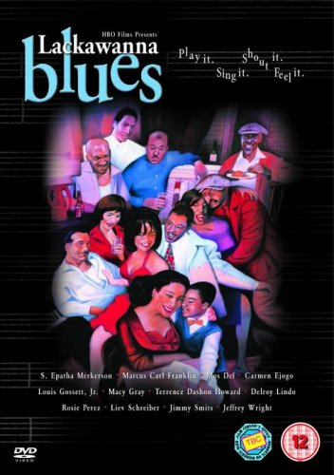 | Lackawanna Blues  In a story fueled by rhythm and blues, a young boy’s life is shaped by love and the stories of a cast of characters in the boarding house where he lives. Based on Ruben Santiago-Hudson’s autobiographical play about his relationship with his guardian Rachel Crosby, set in 1950’s and 1960’s Lackawanna, New York. After the separation of his parents, young Ruben, a part-black, part-Hispanic child, is sent to live in a small-scale boarding house run by the kind-hearted "Nanny" Crosby and her younger husband Bill. (DVD 95 min)  AV DVD 466
 | Senator Obama goes to Africa  Senator Barack Obama travels to the land of his ancestry. From South Africa to Kenya to a Darfur refugee camp in Chad, Obama explores the vast continent that is gaining increasing importance in this age of globalization. (DVD 60 min)  AV DVD 476
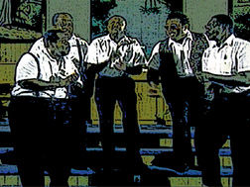 | Too Close to Heaven: The History of Gospel Music  Using narration and performance footage, this film traces the 200 year history of gospel music from black churches, to the civil rights movement, to its influence on modern jazz, blues, and rock and roll. (DVD/3 disc set 51 min. each)  AV DVD 431
 | Flags of our Fathers  The life stories of the five Marines and one Naval officer that were forever immortalized as a symbol of WWII by raising the American flag at the battle of Iwo Jima. (DVD 132 min)  AV DVD 404
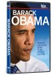 | Barack Obama: From his Childhood Years to his Historic Election  Follow Obama through his teenage struggles for self-identity, his student days at Columbia University and Harvard Law School, and his political career in Chicago. Go behind the scenes of Obama’s extraordinarily successful presidential campaign and his journey towards the 2008 Democratic Convention. (DVD 47 min)  AV DVD 397
 | Keita: The Heritage of the Griot  Based on an important work of African oral literature, the Sundjata epic. When a djéliba, a master griot or bard, arrives mysteriously at the home of Mabo Keita to teach him "the meaning of his name," the boy and griot are inevitably brought into conflict with his Westernized mother and schoolteacher, who have rejected African tradition. The griot reveals to Mabo the story of his distant ancestor, Sundjata Keita, the 13th century founder of the great Malian trading empire. (DVD 94 min)  AV DVD 480
 | CEO Exchange  Meet two CEOS who know how to make a gamble pay off. (DVD 60 min)  AV DVD 490
 | The Probability and Statistics Tutor  Achieve success in probability and statistics by learning the material through fully worked example problems. This course takes you through the fundamentals of probability and statistics in a step-by-step fashion suitable for any class or self study. (DVD/3 disc set 600 min)  AV DVD 422
 | Heat: A Global Investigation  Under pressure from governments, green groups, and investors, big businesses, such as the oil and coal companies, electric utilities, and automobile manufacturers, are promising to reshape their approach to the environment, climate change, and carbon emissions. Shows how some corporations around the world are fighting to fend off new regulations while others are repositioning themselves to meet these challenges. Visits the melting glaciers of the Himalayas, Chinese coal companies, Indian SUV makers, and American oil giants, among other locations. (DVD 120 min)  AV DVD 488
 | The Trigonometry and Pre-Calculus Tutor  The Trigonometry and Pre-Calculus Tutor is the easiest way to improve your grades! How does a baby learn to speak? By being immersed in everyday conversation. What is the best way to learn Trig and Pre-Calculus? By being immersed in it! During this course the instructor will work out hundreds of examples with each step fully narrated so no one gets lost! See why thousands have discovered that the easiest way to higher grades is to learn by examples! This course covers the essential materials necessary to prepare a student for a course in Trigonometry and Pre-Calculus. (DVD/2 disc set 300 min)  AV DVD 421
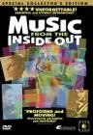 | Music From the Inside Out  An exploration of the magic and mystery of music through the stories, passions, and artistry of the 105 musicians of the Philadelphia Orchestra. Filmed over a period of five years on three continents, the main character of this film is "Music" itself. Incorporating a blend of well-loved musical works--including classical, jazz, bluegrass, salsa, and world music the film features one of the most eclectic soundtracks of any recent documentary. (DVD 90 min)  AV DVD 500
 | Food, Inc.  Explores the U.S. commercial food industry, examining corporate control of supply and market. The film seeks to demonstrate how the incentive for corporate profit can overwhelm consumer health needs, as well as the livelihood of the American farmer, the safety of workers and the environment. Reveals various details of food ingredients and additives, and how a contemporary mass production method of food affects U.S. culture. (DVD 91 min)  AV DVD 493
 | No! Confronting Sexual Assault in Our Community  "No! provides a comprehensive lens through which to examine the impact of sexual violence on black women and girls -- calling to task in particular the behaviors and attitudes of black men in reinforcing a cultural assault ... No! includes messages from violence prevention advocates as well as testimonials from survivors who defy victimization ..."--Container. (DVD 92 min)  AV DVD 487
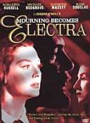 | Mourning Becomes Electra  Adapted from the classic play by Eugene O’Neill, set in a time near the end of the Civil War. Poisoning, infidelity, gunshots and shocking family secrets explode in a haunting climax that will never be forgotten. (DVD 157 min)  AV DVD 464
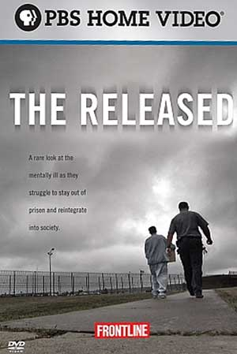 | The Released  Examines what happens to the hundreds of thousands of mentally ill prisoners when they leave prison and why they return at such alarming rates. Includes the intimate stories of the released, interviews with parole officers, social workers, and psychiatrists. (DVD 60 min)  AV DVD 494
 | Accounting: Using Ledgers  The Standard Deviants uncover the dark secrets of the double nature of accounting, and expose Stan’s unique television network. There are also the hidden mysteries of double-entry accounting, the ledger, balancing accounts, and the general ledger. (DVD/2 disc set 26 min. ea.)  AV DVD 415
 | The Ascent of Money: Boom or Bust  Bestselling author, economist and historian Niall Ferguson takes a look at how money evolved, from the concept of credit and debt in the Renaissance to the emergence of a global economy and the subprime crisis we face today. (DVD 116 min)  AV DVD 484
 | The Merchants of Cool: A Report on the Creators & Marketers of Popular Culture for Teenagers  The world of advertising has become inundated with marketing for teenagers. This episode of Frontline explores the pop culture manipulated and created by corporate America for the American youth. (DVD 60 min)  AV DVD 486
 | Unnatural Causes: Is Inequality Making Us Sick?  A seven-part documentary series arguing that "health and longevity are correlated with socioeconomic status; people of color face an additional health burden, and our health and well-being are tied to policies that promote economic and social justice. Each of the half-hour program segments, set in different racial/ethnic communities, provides a deeper exploration of the ways in which social conditions affect population health and how some communities are extending their lives be improving them"--Container insert. (DVD 236 min) AV DVD 481
 | bell hooks: cultural criticism & transformation  Bell Hooks makes a compelling argument for the transformative powers of cultural criticism. She demonstrates how learning to think critically was central to her own self-transformation and how it can play a role in the students’ quest for a sense of agency and identity. Includes footage from many films and music videos, and news coverage. (DVD 66 min)  AV DVD 479
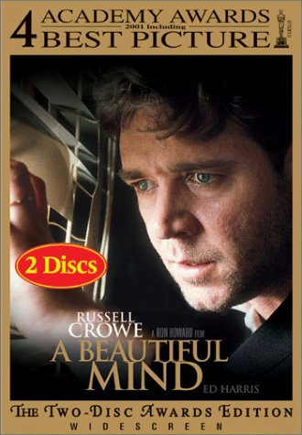 | A Beautiful Mind  Dramatic biography of John Nash, a mathematical genius, who made an astonishing discovery early in his career and stood on the brink of international acclaim. But the handsome and arrogant Nash soon found himself on a painful and harrowing journey of self-discovery. After many years of struggle, he eventually triumphed over his schizophrenia, and finally, late in life, received the Nobel Prize. (DVD 135 min)  AV DVD 410
 | Barack Obama: The Power of Hope  Historic footage from Barack Obama’s 2008 presidential campaign and 2009 inauguration, including the Iowa caucus victory speech, key debates, and inaugural speech. (DVD 13 hr., 36 min)  AV DVD 721 Disc 1-3
 | Crips and Bloods: Made in America  A cluster of neighborhoods lies in the heart of Southern California, streets that form a grid between concrete ribbons of freeway. Nearly a quarter of its young men will end up in prison. Many others will end up dead. These neighborhoods in South Los Angeles are home to two of the most infamous African-American gangs, the Crips and the Bloods. On these mean streets over the past 30 years, more than 15,000 people have been murdered in an ongoing cycle of gang violence that continues unabated. Here is where America’s most bloody and costly outbreaks in civil unrest erupted - not once, but twice, 27 years and just three miles apart. Combines archival footage with in-depth interviews. (DVD 99 min)  AV DVD 483
 | Sybil  A wrenching true story of a woman whose tortured childhood shattered her into multiple personalities. (DVD 187 min)  AV DVD 477
 | Sharpe’s Revenge Collection Set (5 discs)  A maverick British officer lives a life of adventure during the Napoleonic wars. Based on the novels by Bernard Cornwell. (DVD/5 disc set 500 min)  AV DVD 473
King of the Infomercial: A.J. Kumani (ABC News Nightline)

There’s a fine art to selling earlobe lifts, inflatable massage boots, and mini-staircases for arthritic dogs. This ABC News program enters the strange world of A. J. Kubani and his New Jersey-based company, Telebrands, a purveyor of quirky household products showcased in late-night TV infomercials. In a one-on-one interview, Kubani discusses his main strategy: identifying a mundane, irksome problem and immediately offering a quick fix. "Preventions don’t sell," he declares, demonstrating a keen awareness of his customer base while conceding the hit-or-miss nature of his product line. The program also provides a behind-the-scenes look at pitching and shooting a Telebrands infomercial. (DVD 12 min)

AV DVD 446
 | Obama: All Access  60 Minutes tracks the rise of Barack Obama from Senator to President with behind-the-scenes access over a two-year period. Contains material from six separate broadcast segments, and includes major public appearances and speeches. (DVD 240 min)  AV DVD 396
 | Zora’s Roots: The Life of Zora Neale Hurston  This program examines the life of author and anthropologist Zora Neale Hurston. The film follows Hurston, best known for her novel, Their Eyes Were Watching God, to the subtropical paradise that shaped her childhood and her life’s work - where she returned again and again for inspiration and solace. This documentary tells her story through the people who knew her and the places and events that she brought to the world through her writing. (DVD 60 min)  AV DVD 262
 | Probability  Contents description from container: Introduction to probability, simple probability, joint probability, the addition rule, the multiplication rule, counting principles, permutations, probability and permutations, combinations, probability and combinations, binomial distribution, conditional probability, Bayes’ Rule, expected value of a probability distribution. (DVD/2 discs 4 hr)  AV DVD 456
 | A Moment in History: The Inauguration of Barack Obama  Features one of the most important events in history, and includes the pre-inaugural events from the morning of January 20, 2009, the Oath of Office and Inaugural Speeches in their entirety, benediction from Dr. Joseph Lowery, recitation by Elizabeth Alexander, and much more. (DVD 150 min)  AV DVD 720
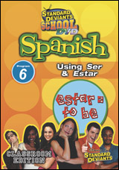 | Spanish: Using Ser & Estar  Learn the basics of the Spanish language. (DVD/3 disc set 15 min. each)  AV DVD 412
 | Spanish: Using Articles & Pronouns  Learn the basics of the Spanish language.(DVD/3 disc set 15 min. each)  AV DVD 412
 | Hip-Hop: Beyond Beats & Rhymes  A look at the conceptualization of masculinity in hip-hop culture. Includes interviews with prominent rappers, music industry executives, and social critics. (DVD 61 min)  AV DVD 447
 | Let Freedom Sing: How Music Inspired the Civil Rights Movement  One of the most powerful movements in American history is told through the singers and songwriters who fought for change with their music. Highlights include the influence of WDIA radio in Memphis and the influence of Harry Belafonte, Phil Ochs and other performers. (DVD 102 min)  AV DVD 501
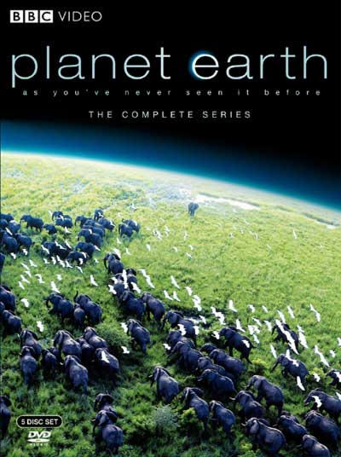 | Planet Earth: The Complete Series  This eleven part series presents a tour of the entire planet Earth, including the poles, mountains, waters, caves, deserts, plains and jungles. Using high-definition photography and revolutionary ultra-high speed cameras, this series captures rare action, impossible locations and intimate moments with our planet’s best-loved and most elusive creatures. (DVD/5 disc set 823 min)  AV DVD 505
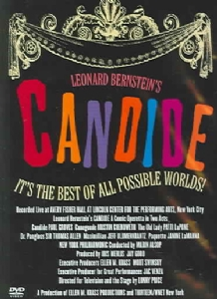 | Leonard Bernstein’s Candide: A Comic Operetta in Two Acts  Leonard Bernstein’s brilliant comic operetta is based on the classic Voltaire tale of an innocent young man’s journey through a life filled with colorful characters and unexpected life lessons. Performed in concert-style. (DVD 116 min)  AV DVD 465
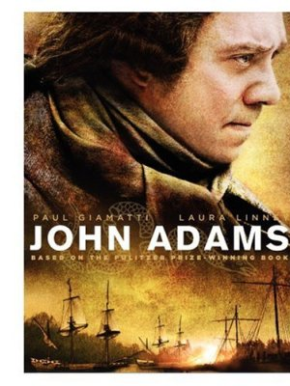 | John Adams  While our new nation was suffering attacks from both within and without, John Adams had a vision of a nation of liberty and justice for all. He guided his peers--General George Washington, Benjamin Franklin and Thomas Jefferson--in setting the values and agenda for a glorious, free America. Adams and his wife Abigail refined these ambitious democratic ideals, and their partnership became one of the most moving love stories in American history. (DVD/3 disc set 501 min)  AV DVD 424
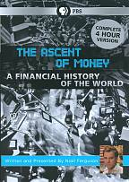 | The Ascent of Money: A Financial History of the World  Bestselling author, economist and historian Niall Ferguson takes a look at how money evolved, from the concept of credit and debt in the Renaissance to the emergence of a global economy and the subprime crisis we face today. (DVD 240 min)  AV DVD 492
 | Buffett & Gates: Go Back to School  The two wealthiest men in America, Bill Gates and Warren Buffett, offer advice to students at a question-and-answer session hosted by the University of Nebraska’s School of Business Administration, addressing such topics as how to get a job, how to achieve success, and how to have a positive impact on the world. (DVD 57 min)  AV DVD 485
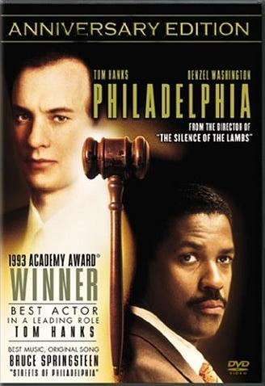 | Philadelphia  Two competing lawyer join forces to sue a prestigious law firm for AIDS discrimination. As their unlikely friendship develops, their courage overcomes the prejudice and corruption of their powerful adversaries. (DVD/2 disc set 125 min)  AV DVD 475
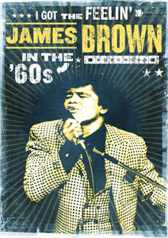 | I Got the Feelin’: James Brown in the ‘60s  From his early start singing in a prison gospel group to his transformation into The Godfather of Soul, James had the feeling. It was real and powerful and managed to jump the color barrier and grabbed a hold of black and white audiences alike. Pays tribute not only to James Brown’s enormous contribution to American music, but also reveals his often overlooked impact on American race relations. (DVD/3 disc 5 1/2 hr)  AV DVD 504
Minds on Campus

Explores the world of student mental health post-Virginia Tech, looking at issues of confidentiality, when schools can and should take action, and the necessity of looking at specifics of individual cases. Includes the perspective of experts in suicide prevention, the mother of a college student who committed suicide, a lawyer, a college administrator, and a psychiatrist. (DVD 15 min)

AV DVD 482
 | ABC News Nightline: Women Gamblers/Anatomy of a Twinkie/Flirt in Traffic  Two decades ago, only a handful of women sought treatment for gambling addiction. Now the number has shot up into the millions. And not just in Las Vegas. In Oregon, casinos outside American Indian reservations are illegal. But Oregon’s lottery operates video poker machines throughout the state, and they’re featured prominently in a chain of popular delicatessens, where the setting might be brighter and less smoky than the stereotypical casino, but the stakes can be just as high. ABC’s Jessica Yellin has the story of one woman who wagered it all, and lost it all. -- The incredible, edible Twinkie. What seems like a simple bit of yellow cake and vanilla filling is in fact the end product of a very complicated process. Though the secret of the Twinkie recipe is very closely guarded, a food writer who is a bit obsessed with the famous confection broke it down into 39 ingredients - yes, 39 . ABC’s John Berman goes inside the Twinkie. -- Ever see someone cute pull up in the convertible next to you? The light changes, the person speeds off, and you never see each other again. Well, a new Web site works to ensure that first fleeting meeting won’t be your last. (DVD 20 min)  AV DVD 507
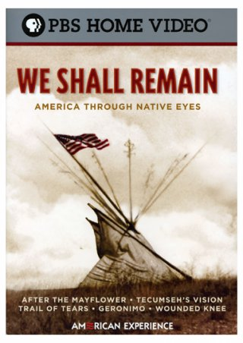 | We Shall Remain: America Through Native Eyes  "They were charismatic and forward thinking, imaginative and courageous, compassionate and resolute, and, at times, arrogant, vengeful and reckless. For hundreds of years, Native American leaders from Massasoit, Tecumseh, and Tenskwatawa, to Major Ridge, Geronimo, and Fools Crow valiantly resisted expulsion from their lands and fought the extinction of their culture. Sometimes, their strategies were militaristic, but more often they were diplomatic, spiritual, legal and political ... These five documentaries spanning almost four hundred years tell the story of pivotal moments in U.S. history from the Native American perspective, upending two-dimensional stereotypes of American Indians as simply ferocious warriors or peaceable lovers of the land"--Container. (DVD/3 disc set 394 min)  AV DVD 506
 | Norton Recorded Anthology of Western Music (Volume One: Ancient to Baroque)  "For use with Norton anthology of western music, 6th edition (Burkholder/Palisca, eds.), and A history of western music, 8th edition (Burkholder/Grout/Palisca)"—Containers (CD/6 disc set)  AV CD 151
 | Norton Recorded Anthology of Western Music (Volume Two: Classic to Romantic)  "For use with Norton anthology of western music, 6th edition (Burkholder/Palisca, eds.), and A history of western music, 8th edition (Burkholder/Grout/Palisca)"—Containers (CD/6 disc set)  AV CD 151
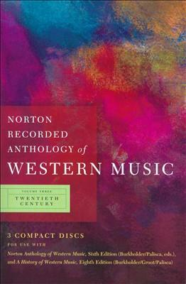 | Norton Recorded Anthology of Western Music (Volume Three: Twentieth Century)  "For use with Norton anthology of western music, 6th edition (Burkholder/Palisca, eds.), and A history of western music, 8th edition (Burkholder/Grout/Palisca)"—Containers (CD/6 disc set)  AV CD 151
 | Let Freedom Sing: The Music of the Civil Rights Movement  (CD/3 disc set)  AV CD 152
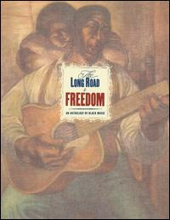 | Long Road to Freedom: An Anthology of Black Music  Bonus DVD special features: "Harry Belafonte’s reminiscence of that special period [i.e. 1960’s] ... biographies of key participants and musicians, web site links, a message from the National Underground Railroad Freedom Center and much more"--Book, p. [9]. (CD/5 disc set + bonus DVD)  AV CD 153
 | We Can’t Afford to be Color Blind: Challenges for Professionals of Color and Allies
 | Models of Writing: Reporting

