TEAL User Instructions for Candidates and Educators

Setting up the TEAL account is a two step process:
1. Set up TEAL user name and password.
2. Set up access to your educator profile.

Step 1: Requesting a TEAL New User Account
Go to the TEA website at www.tea.state.tx.us . You are on the “official TEA website” if you see student artwork and a TEA logo.
A. In the upper right hand corner, click on the box Educator Login (Internet Explorer required). See circled area below.

B. The next screen that you will see is the one below. Select the “Follow this link to create a new TEAL user account”. Click on the red underlined link in the red box indicated below.
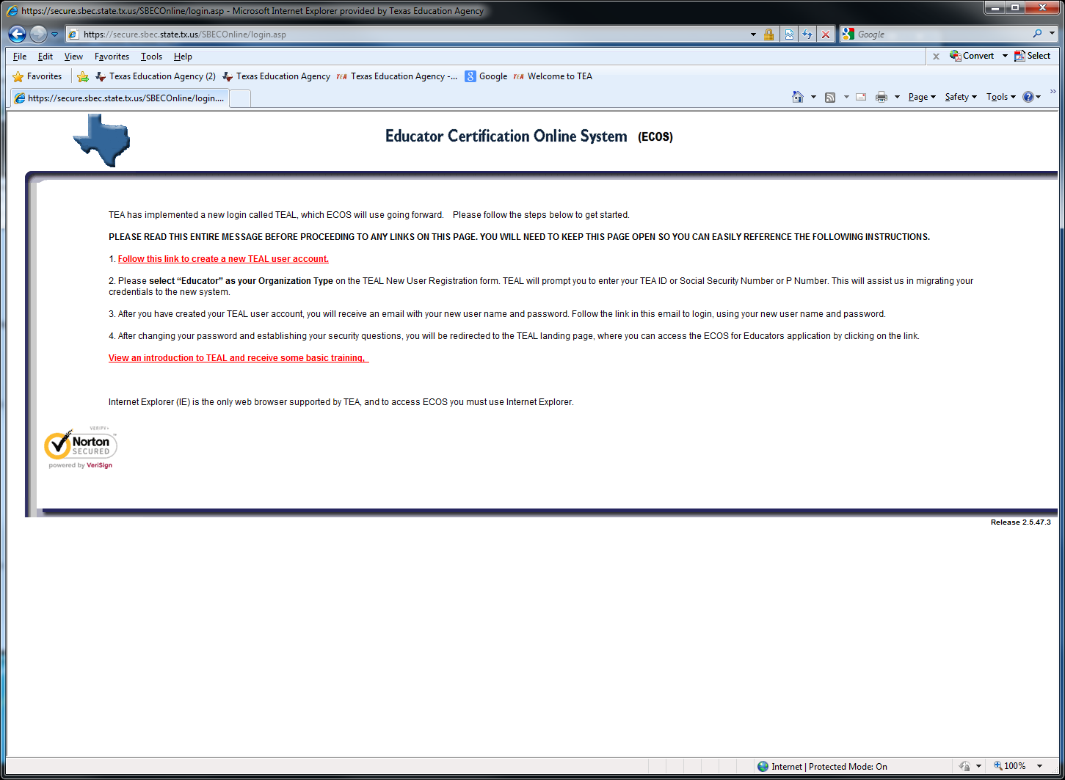

C. The next screen that you will see will require you to provide information on yourself. The areas that have the red asterisk are required to be completed. It is critical that your email address be correct because you will be sent a user name and a temporary password.
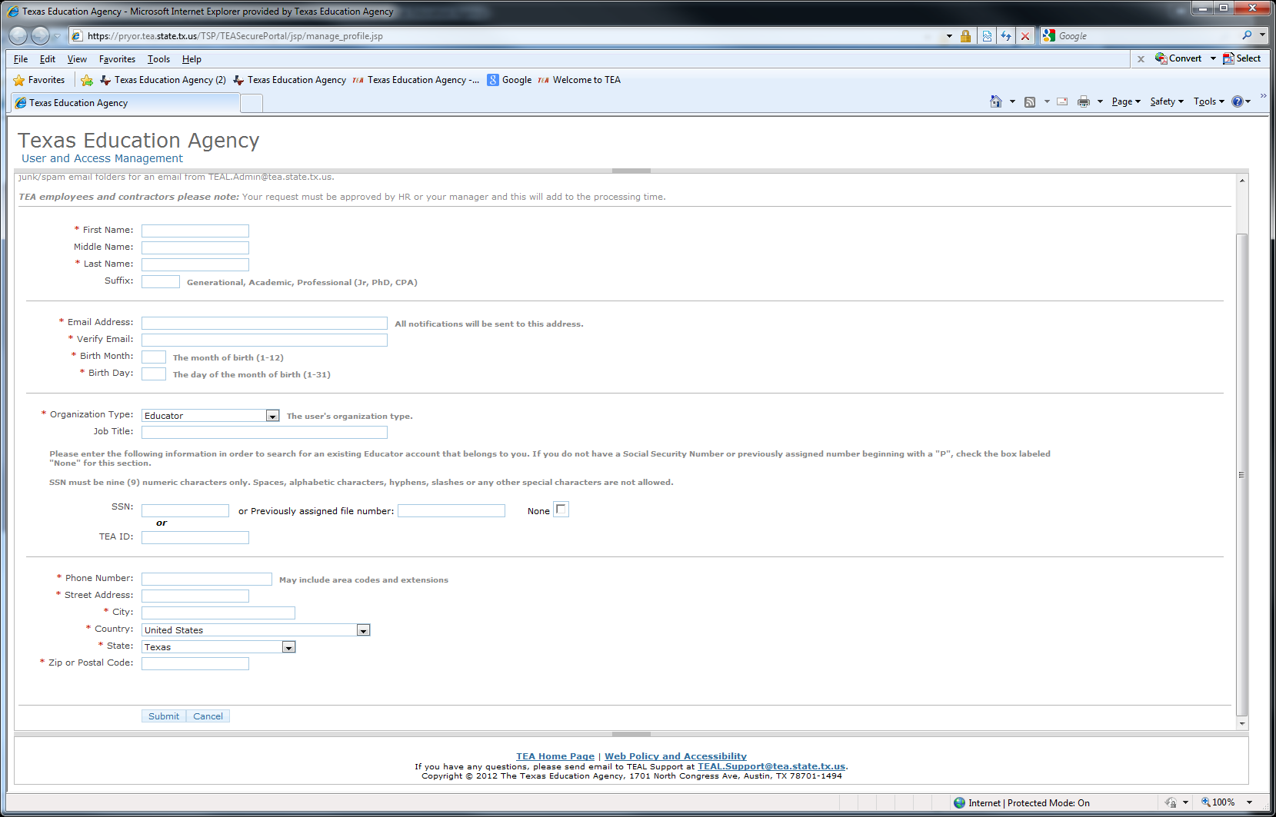To access to the ECOS for Educators application, please select “Educator” as your “Organization Type” from the drop-down list (in large red box). Enter information exactly as it appears on your driver's license/state identification and in your personal online account (if your name has changed, please review the information change instructions at the end of this training).

Next, you will be prompted to enter your Social Security Number, or TEA ID, or P Number (if you do not have a social security number) so that TEA can transfer your credentials appropriately.

When you have completed the form, click the Submit button (small red box).
A message will appear at the top of the page acknowledging your request.
Click on the “done” button at the bottom of the page. Wait for the email from TEA with your user name and password. When it is received, read the email carefully and follow instructions for setting up TEA access.

Logging in and Out of TEAL for the first time
After you receive your user name and password, you will need to login into your account again if you logged out. Go to the TEA website again. This time, select the TEASE & TEAL Secure Applications button circled below.
Select the TEAL Login button.

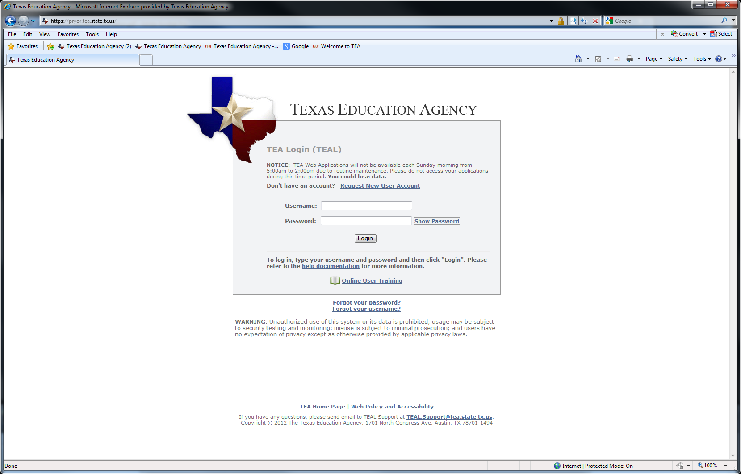The login page will appear. Put in the user name and password you received by email from TEA. It is suggested that you copy and paste the password into the box. Click Login.

When you log in for the first time, you will receive a message “Your password has expired. Please set a new password to continue.” Before setting the new password, consider the password guidelines:
- Must be 8-30 characters
- Must contain the following character types: letters, numbers, and special characters (for example - #, *, $, or @)
- Must not include your username
- Must not contain variations of the word "password"
- Must not contain a character repeated more than 2 times
- Must not be the same as your previous ten passwords
You will need to create a new password that you will be able to remember. Be sure you write your new password down or put it in your notes on your phone.
- Click in the Current Password (it may say old) text box to enter the password you received by e-mail. The old password is a mixture of different numbers and symbols. It is suggested that you copy and paste the password into the box. Type and retype a new password in the New Password and Confirm New Password fields. Click the Submit button. If you receive a message that the password has been rejected for policy reasons, it means that you did not follow the guidelines for the password. Improve your password, and try again.

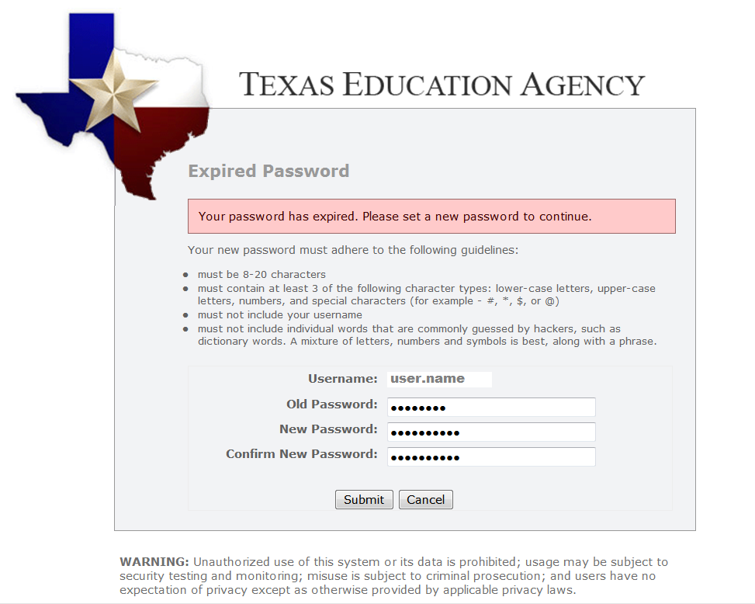
- After your password has been changed, a Statement for Assurance of security provisions will appear. You must agree to these provisions to continue. The same provisions will appear at login every 30 days.
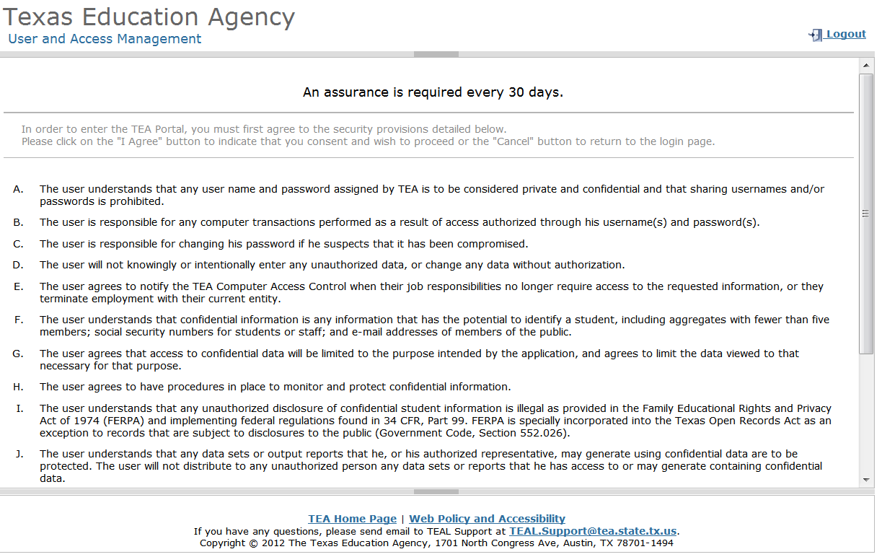
- Read the assurance provisions and click the I Agree button at the bottom of the page. If you do not agree to the security provisions, click Cancel to exit the application. However, you will be unable to access your educator profile in the TEAL system.

- After you agree to the assurance provisions, the security questions page appears.
- The next screen will ask you to choose three security questions. The answers to these three questions will be used to recover your password if you forget or lose it. The answers are confidential and will not be used for any other purpose. Be sure to note the exact answer because the computer needs the exact response. For example, suppose you use the question “In what city did you meet your spouse/significant other?” and type the answer Ft. Davis, Texas. If, you type the answer Fort Davis, Texas or Ft. Davis, TX, the computer will not recognize that answer as correct.
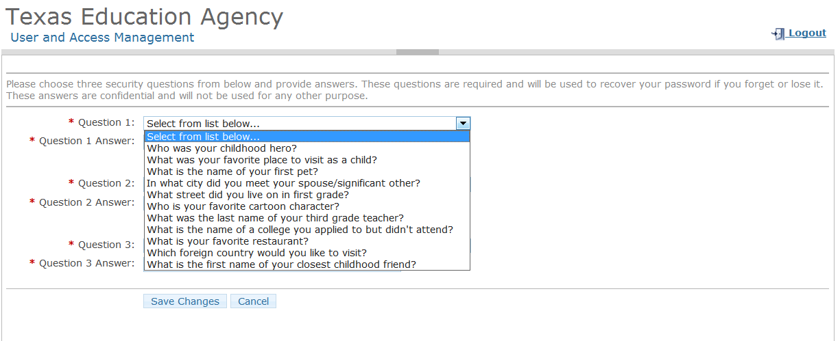
Click in the Question Answer boxes to enter your responses.
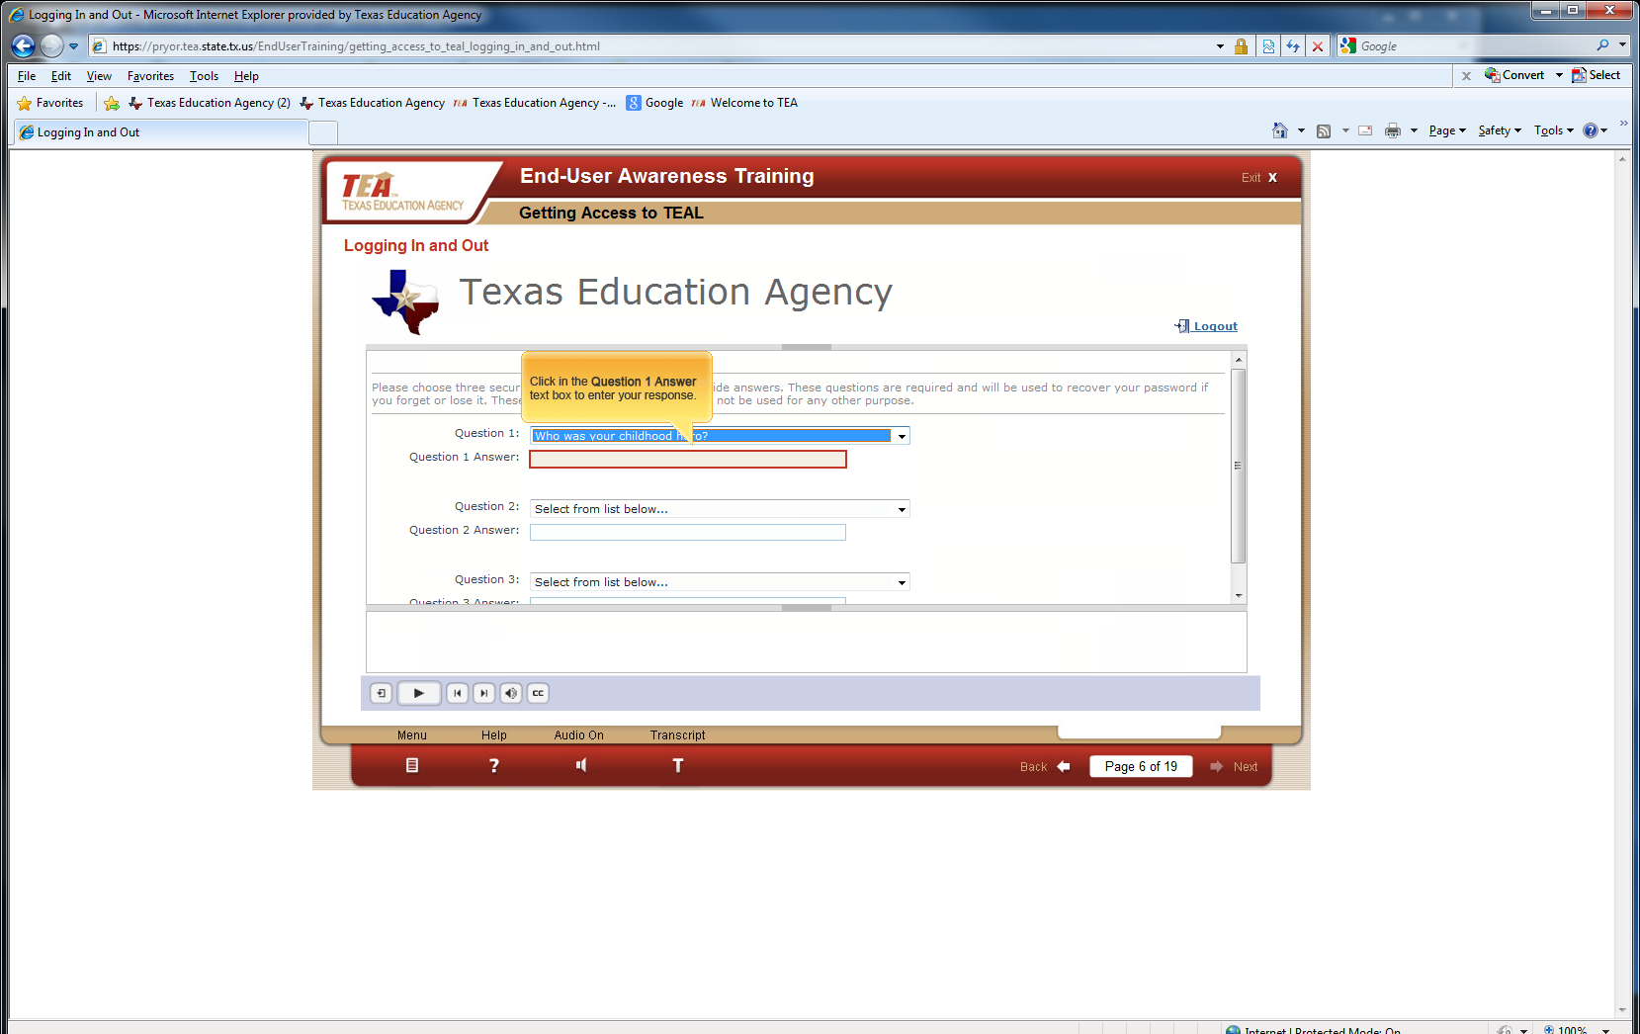
- Click the Save Changes button
- A message appears at the top of the page in green writing that your challenge/response answers have been updated.

Step 2: cREATION OF A NEW aCCOUNT OR Transfer OF Credentials IF YOU HAVE AN EXISTING EDUCATOR PROFILE
Next, the TEAL Applications page appears.
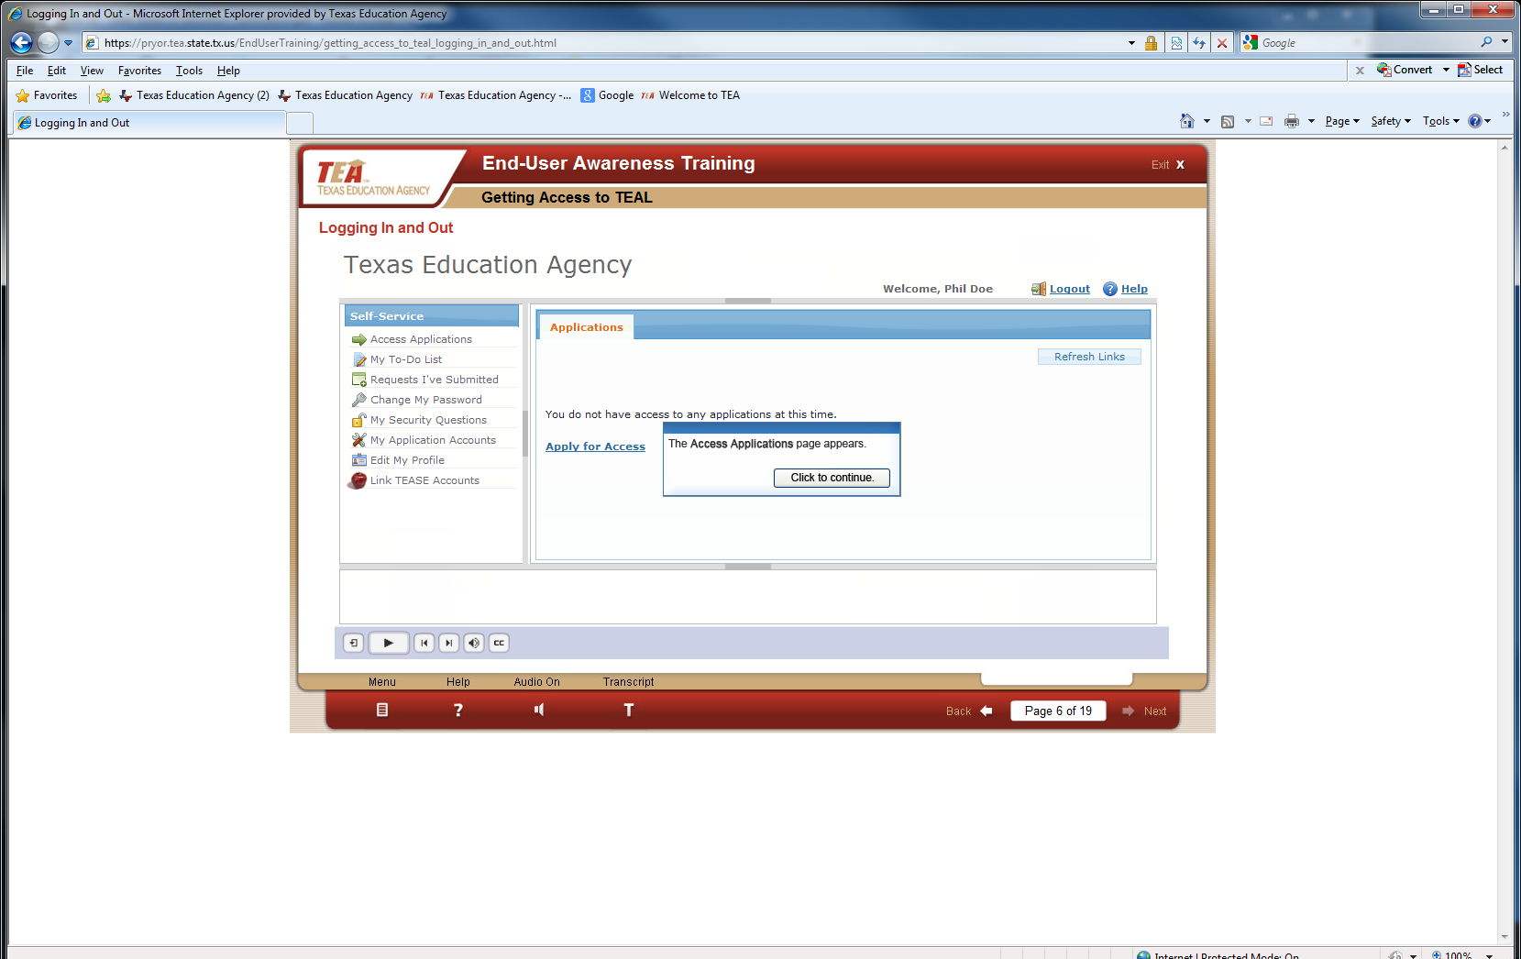

Educators who have existing educator profiles AND new educators needing to set a profile up will be prompted to transfer or establish their user credentials (roles and permissions).
The next screen is the Application Accounts which allows you access to your educator profile.
1. Click My Application Accounts button on left hand menu (A).
2. Click Request New Account button in “My Accounts” page (B).
3. Double click on ECOS for Educators row in the list of available applications (C).
4. Click Go to Account Details Form button at bottom of page (D).
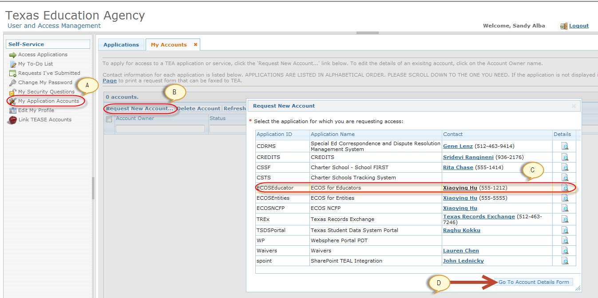
You will be asked whether you have an existing TEA Educator Certification Online System (ECOS) account and password.
PUT NO!
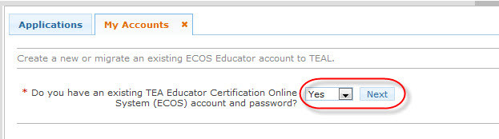
Select “NO” from the drop down box. Click the Next button.
You will see a screen that will ask for your social security number or your TEA ID number. Put in your Social Security Number or P Number. Click the “Create” button. DO NOT PUT IN YOUR TEA ID NUMBER. A message will be displayed indicating your credentials were successfully created and TEAL will create a new Educator account. A red error message means the attempt to create a new account failed. Please follow the message instructions to find out what to do next.

Accessing an ECOS Application
After you have requested and been granted access to an ECOS application, log out and log back in. You can easily access your educator profile by clicking the Access Applications link in the Self Service bar. When you select the access link, you will see Educator Certification Online for external educator users, the word Educator that is underlined, and your TEA identification number. To login and in all future logins, click on the underlined word Educator to access your educator profile. The next screen will show your demographic information. Be sure to keep your information updated. After checking your information, click continue to apply for certificates, pay for services, and print your certificates.

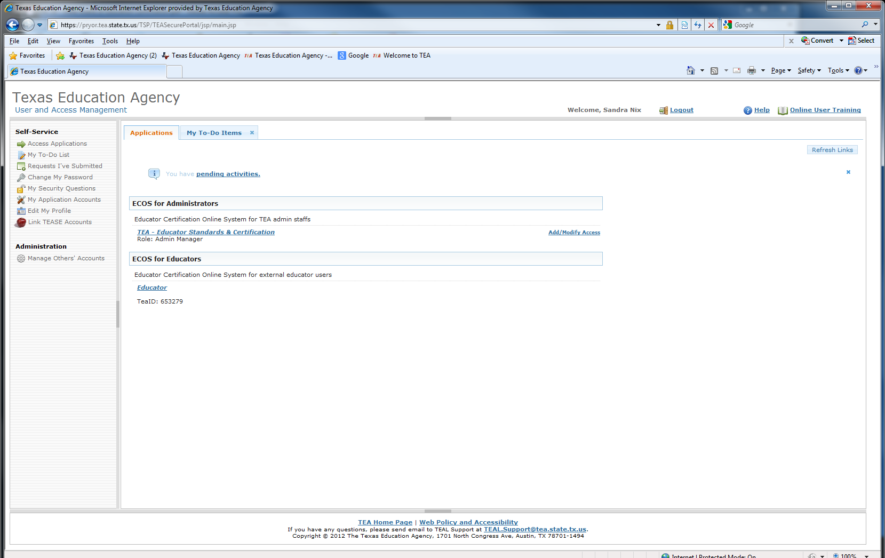

Submitting a Change or Correction of information
To submit a change or correction of name, gender or date of birth, please fax, scan and attach to email or mail the following required information and documents:
- A daytime phone number.
- Copy of your Social Security Card
- Texas Drivers license or State ID
- If changing a first name you must also submit a copy of your birth certificate or court name change document
- Out-of-Country educators who do not hold a social security card may submit a copy of a current passport
- A current email address and valid daytime phone number

Documents may be faxed to 512-936-8277

Or

Mailed to:

TEA-CRT
5th Floor
1701 North Congress Ave Austin, TX 78701.

Please allow 7 to 10 business days for processing November through March. Please allow 15 to 20 business days for processing April through October.

